Project Report: Business Intelligence

1. **EXECUTIVE SUMMARY**

In this report we will discuss about our client company Moneycontrol, which is a stock analysis firm, and provide them with BI solutions which will help them to improve their company results and profits. Before discussing about our BI solution, we will go through our goals for our BI solutions, what challenges we faced, and summary of our deliverables

**1.1 Goals of BI solution:**

Right now, Moneycontrol, our client company, is operating at a teenage level. within the BI maturity model. They still need to make a lot of improvements in that area, even though they currently employ BI tools to provide their customers with their analysis. As an illustration, we looked at Bloomberg, a well-known provider of stock analysis services that uses both technical and fundamental analysis of the stocks. This concept can also be used by Moneycontrol which has the potential to draw in lots of new clients. regarding their application.

**1.2 Our Deliverables:**

Through our BI solution we will provide Moneycontrol with some deliverables that are as follows.

* **Integrate BI technologies:**

Through BI solutions will provide Moneycontrol with prototype dashboards. These types of dashboards will include all types of analysis related to a company. Be it the technical analysis or fundamental analysis to give the ease of insights to all the investors for efficient and good decision making regarding their investments.

* **Datasets used-**

Since Moneycontrol focuses more on Indian market, we have taken the data set of selective companies from National Stock Exchange. For fundamental analysis we have taken the quarterly summary of each of the company and for the technical analysis we have done web scraping through a Python script.

* **Access to Fundamental and Technical Analysis-**

We have divided these dashboards into two types. The first one, technical analysis, where the analysis is related to the stock price, the volume of the shares traded, the average price within the last few trading sessions, the open, high, low, and close prices of the company, etc. The second one is the fundamental analysis; it is about the financial status and financial reports of the company. It may include the net profit, sales, depth, and dividend of the companies. We can use these ratios to compare the companies in a similar segment over a particular time.

* **Enabling Data Driven and Event Driven decision-**

Financial institutions like Bloomberg incorporate BI technologies to display data of companies which can be related to a particular event like expert opinions, or it can be information related to new product launch which may affect the stock prices and the fundamentals of our companies. We are using a similar approach where we are presenting our data into two dashboards using all factors which can influence the price of the stock, and which can help investors make a better investment decision.

**1.3 Problem addressed:**

* **Lack of using business intelligence tools:**

Since Moneycontrol already has a collaboration with Tableau, we noticed that they are not utilizing its BI (Business Intelligence) technologies to the fullest. They are only showing the real-time data of the stocks on the dashboards with some of the information about the stocks, we tried to improve those dashboards by showing multiple information about a stock and upgrading their BI structure in a better way.

* **Basic Technical analysis:**

While researching about Moneycontrol, found that their current dashboards only portray real-time stock data along with some of the technical parameters. We believed that there were a lot of scope into the improvement of those analysis by upgrading their technical analysis and including fundamental analysis into the dashboards such as Bloomberg did in their past years.

* **Lack of KPIs (key performance indicators) in Dashboards:**

Although Moneycontrol was showing valuable real-time stock data in their dashboards, they did not include KPIs (key performance indicators), to improve the insights they provided to their investors. This could give their investors better decision-making ability as well as attract new investors who are planning to invest in the stock market to choose Moneycontrol.

* **Not fully utilising the data.**

Although Moneycontrol has complete access to NSE (National Stoch Exchange) data, currently they are only using real-time data for their technical analysis, so we tried to include all the data provided by NSE, whether it is the real-time data or the quarterly financial reports of the companies, to create both of our dashboards.

1. **INTRODUCTION**

For this project, we have taken our client company as Moneycontrol. Moneycontrol is India's No. 1 Financial and Business portal. With in-depth market coverage, analysis, expert opinions and a gamut of financial tools.



**2.1 Company Background:**

Moneycontrol is a 15+ years old company and a part of Network 18 group, which is owned by Reliance Group. It a prominent financial news and information platform based in India.

**2.1.1 History of the Company**

Quoting Moneycontrol itself, here is the history of the company:

“*For a financial portal born in late 1999, just when bursting of the dotcom bubble was about to nearly bring down both financial markets and the fledgling worldwide web, we couldn't have chosen a more difficult time to launch. But it was really passion and belief that saw us through. A single-minded passion to become the country's greatest resource for financial information on the Internet. And the belief, that through it, we would be able to make a difference to people's financial lives.*

*Since 1999 through to today we have been there to chronicle the growth of the Indian economy. Along with it, we have grown as well; starting off as a financial portal that began by offering end-of-day stock prices to today arguably becoming India's biggest store of news (text and videos), analysis, data and tools on investing (across diverse asset classes), personal finance, the business sector and the economy.*

*moneycontrol.com today gets over 17 million visitors every month across all its platforms-web, mobile and tablets that makes it the largest online financial platform in India. But while we've radically changed and evolved, the belief and passion to be the best and the most insightful hasn't. That, we hope, keeps us ticking. This we believe is merely the start of our journey.*” [1]

**2.2.2 About the Company:**

Moneycontrol works in the media and financial services sectors. Its main goal is to give traders, investors, and the general public thorough financial news, analysis, and information. Money Control provides various services to its customers such as:

* Real-time information on stock prices, indexes, and other financial instruments that are provided by the stock market data source.
* Financial news: Comprehensive and timely coverage of global and domestic financial news.
* Tools for managing and keeping track of an investor's investment portfolio.

The primary goals of Moneycontrol are to deliver news, analysis, and financial data that is relevant to the Indian market. Coverage of Indian equities, indexes, financial news, and economic indicators that have an immediate impact on the nation's businesses and investors. Although its primary focus is the Indian market, Moneycontrol also offers coverage of international financial markets. Approximately 500–1000 people are currently employed by the company.

**2.2.3 Scope of the Project:**

Since Moneycontrol already has access to all the data for the real-time stock data and the financial news of the Indian market. They still lack the visual appeal of the dashboards for both analysis. Apart from that they don’t summarize the financial parameters from the financial reports of the companies and display it visually to their customers. It can be very important to display the fundamentals of the companies. Hence there is a lot of scope of improvement in the department of visualisation in the company.

**2.3 Current status of BI and Analytics:**

Moneycontrol is quite an experienced company in the field of finance, they have progressed in the BI maturity Model. Through our analysis, we have determined that Moneycontrol is at the teenage of the BI maturity model. 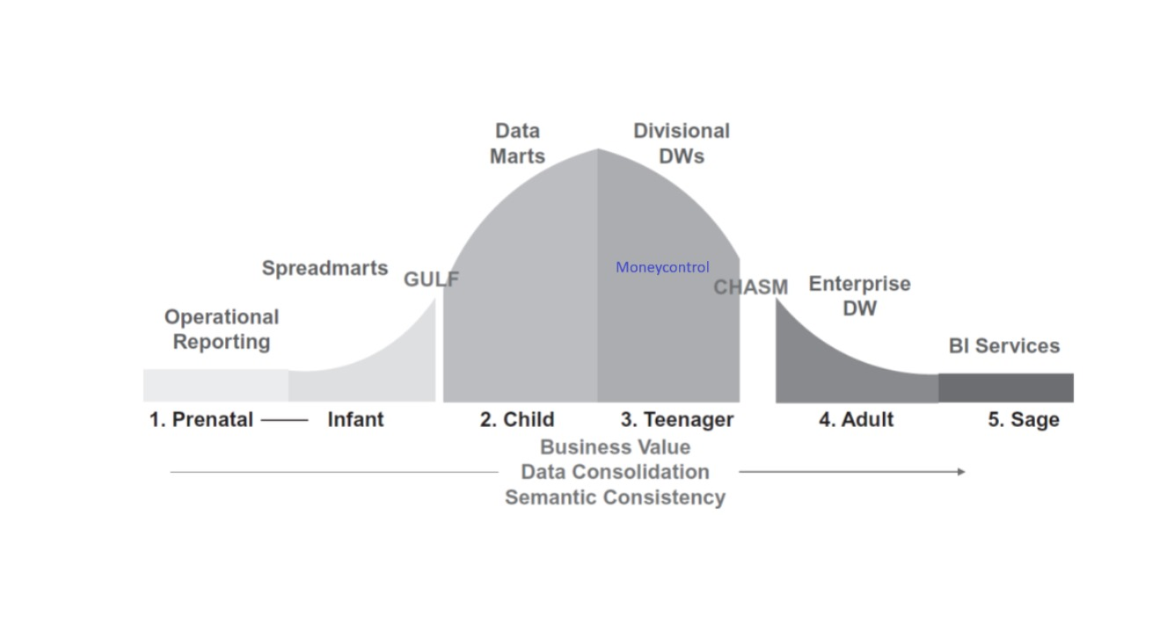

The company has switched from MS Excel to using Data Warehousing for a while. They also use dashboards to display their technical analysis on their website as well as collaborated with Tableau.



Crucial indicators that Moneycontrol is at the teenage stage of the BI Maturity Model are as follows:

* Using Data Warehousing
* Displaying Dashboards
* Collaborations with Tableau for BI Analytics
* Technical Dashboards

Apart from these features Moneycontrol also uses various other technologies as follows [2] :

* Traffic Analysis Tools: Google Analytics, Facebook Pixel
* Advertising Networks: Google Ads, Amazon Associates, OpenX,
* Tag Manager: Google Tag Manager

**2.3 Case Studies and Inspiration**

The inspiration for this project was taken from Bloomberg Inc. Through the Bloomberg Terminal, Bloomberg L.P. offers financial enterprises and organizations enterprise applications and financial software solutions like news, data services, analytics, and equities trading platforms. Bloomberg is useful not just for market and news monitoring but also for analysing specific stocks. The analytics offered by Bloomberg are rather extensive and include a wide range of important asset classes, such as mutual funds, stocks, fixed income, currencies, commodities, and exchange-traded funds (ETFs). Bloomberg is a global leader in public health, education, climate change, and other pressing issues affecting the United States and the rest of the world. [3]



**2.3.1 Case Study 1 - Data Driven Decision Making Using BI**

Data Driven Decision making refers to using real time data from various sources and performing analytics and visualization to generate useful insights for investors which helps them make efficient investment decisions based on their goals.

The case study quotes:

“*Making business decisions backed up by high-quality data, deep analysis, and valuable*  *insights is critical to making the most informed business de decisions. According to a survey,*  *companies that were mostly data-driven had 4% higher productivity and 6% higher profits*  *than the average.*” [4]

The case study explains how BI having to help make data-driven decisions helped Bloomberg progress and how other companies who use data-driven decisions tend to have higher productivity and profits than average.

**2.3.2 Case Study 2 – Using Cloud to make Event Driven Decision Making**

Event-driven decision-making using the cloud refers to integrating BI services on cloud servers and performing all the analytics on virtual machines via the cloud so that all types of investors have access to these insights and don't need to buy expensive machines and GPUs to run analytics tools provided by Bloomberg.

The case study quotes:

*“Bloomberg is the only financial data provider to enable cloud-native access to tick-for-tick data. B-PIPE offers global real-time access to comprehensive, consolidated market data with industry-leading data normalization and intelligence, including access to 35 million instruments, over 330 exchanges and 80 billion ticks a day.”*

*“The Google Cloud B-PIPE connectivity model uses Bloomberg’s Open API (BLPAPI), which can provide consistency and resiliency for hybrid and multi-cloud deployment strategies, helping to ensure new client data applications are automatically cloud-ready.” [5]*

Bloomberg’s real-time solutions on Google Cloud can offer the financial services industry flexible and optimized cloud delivery with numerous benefits, such as:

* Ease of deployment: Customers can access the highest performance real-time data without the need to manage hardware or install software.
* Speed of development: Firms can rapidly connect developers and their applications to market data, which can dramatically speed up the creation of new environments for development projects.
* Efficiency: Companies can lower their total cost of ownership (TCO) by simplifying technology infrastructure in the public cloud.
* Fully managed: Customers can benefit from high-quality data and excellent customer service that distinguishes Bloomberg and B-PIPE.
* Enhanced accessibility: Customers can experience simplified access to the data, when and where needed, with limited friction.

1. **PROPOSED BI SOLUTION**

To explain our BI solution, first, we need to understand what BI is and why is BI necessary for Moneycontrol.

**3.1 Introduction to Business Intelligence -**

* Business intelligence, or BI, is a term used to describe a collection of techniques that give firm information and data software an overview of business activities, both historical and current, to business owners. Owners of businesses can utilize this data to streamline workflow through improved technology, processes, and communication.

**3.2 Data Integration-**

* We have integrated fundamental and technical data from the National Stock Exchange website to ensure that the dataset is comprehensive and reflective of diverse financial metrics.
* We have scraped the quarterly analysis data for each company from its website.
* We integrated data from the same source to ensure the consistency and reliability of the dataset for accurate analysis.

**3.2.1 Data Warehousing:**

* The organized storage of integrated data from multiple sources is known as data warehousing, and it offers an organized setting for effective reporting and querying.
* Data warehousing is essential to our stock market analysis project because it provides a solid framework for organizing and storing historical market data. By combining data from many sources, we build an extensive repository that makes analysis and retrieval easier.
* To store the combined technical and fundamental data that we obtained from the National Stock Exchange website, we built a special data warehouse. This centralized repository improves overall speed while also optimizing data retrieval and analytical processes.

**3.2.2 Data Analysis-**

* For the data analysis we implemented a correlation matrix which presents the correlation between different columns of the dataset.
* Using this correlation matrix, we were able to clearly identify the relationships between the various columns in our dataset.
* The visual provided by Tableau made us derive meaningful insights from the technical and fundamental data we integrated.
* The trend analysis we implemented enhances the decision-making process for the users.

**3.3 Reporting and Dashboards-**

* We have created two Dashboards i.e. Fundamental and Technical.
* Fundamental analysis Dashboard help the users to understand the financials of the company like Net profit, Loss, Dept to Equity ratios, Book value, earning per share, Return on net worth.
* Technical analysis Dashboards helps the users to understand the technical data of the company like stock price, moving average, volume of stocks traded, 52-week high-low ratios etc.
* By using tableaus visualization capabilities, our dashboards explain the data in an aesthetically pleasing manner which aids in quick comprehension of the complex financial data.

**3.4 Business Intelligence Governance-**

* Security and Exchange board of India Regulates and protects the interests of investors in securities and promotes the securities market.
* It aims to inculcate a safe investment environment by implementing several rules and regulations and formulating investment-related guidelines.
* It governs the work that is assigned to participants such as international portfolio investors, depositors, credit rating agencies, and securities custodians.

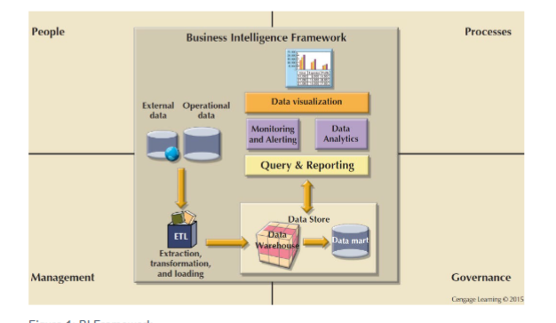

1. **PROTOTYPE AND USE CASES**

**4.1 Datasets -**

We have used two different datasets based on the requirements of our proposed BI solution for Moneycontrol. Since, Moneycontrol currently focuses on Indian financial markets, we have used the dataset of 3000 publicly listed companies in the financial markets of India. The dataset is divided into Technical and Fundamental Data. The technical data of a company refers it’ s Stock Price, Volume Traded, etc and the fundamental data of a company which refers to the Net Profit, Debt to Equity Ratio, Book Value, etc. The datasets are further divided into:  
  
**4.1.1 Dataset for Technical Analysis** -

* The dataset consists of information such as Stock Price, Volume Traded, Moving Average, Change in Price, and Change in Volume related to the shares of a particular company.
* We have performed web scrapping to obtain this dataset using programming languages like Python and in-built libraries like Pandas and Yahoo Finance.
* The dataset is obtained from the official website of the National Stock Exchange of India.
* Since, Moneycontrol is currently focusing on the Indian companies, we have obtained the dataset of all the 3000 companies listed on the National Stock Exchange of India and Bombay Stock Exchange.
* For the scope of this project, we have shortlisted 25 companies on a range of worst-performing to best-performing for the 1st Quarter of the 2023-2024 Financial Year.
* These companies are shortlisted based on Technical Parameters like Current Market Price, Volume Traded, Exponential Moving Average, Change in Price, Change in Volume, and Fundamental Parameters like Net Profit, Debt to Equity Ratio, Return on Net Worth and Earnings per share.
* Stock Price - Every publicly-traded company, when its shares are issued, is given a price – an assignment of their value that ideally reflects the value of the company itself. The price of a stock will go up and down in relation to several distinct factors, including changes within the economy, changes within industries, political events, war, and environmental changes.
* Volume Traded - Volume is the amount of an asset or security that changes hands over some period, often over the course of a trading day. For instance, a stock's trading volume refers to the number of shares traded between its daily open and close. Trading volume, and changes in volume over the course of time, are important inputs for technical traders.
* Moving Average - moving average (MA) is a stock indicator commonly used in technical analysis. The reason for calculating the moving average of a stock is to help smooth out the price data by creating a constantly updated average price. By calculating the moving average, the impacts of random, short-term fluctuations on the price of a stock over a specified time frame are mitigated.
* Price Change - A price change in the stock market is a shift in the value of a security or another asset to either a higher or lower level. The term also refers to the difference between a stock's closing price on a trading day and its closing price on the previous trading day.
* Volume Change - Volume is the amount of an asset or security that changes hands over some period, often over the course of a trading day. For instance, a stock's trading volume refers to the number of shares traded between its daily open and close. Trading volume, and changes in volume over the course of time, are important inputs for technical traders.

**4.1.1 Dataset for Fundamental Analysis -**

* The dataset consists of information such as Net Profit, Earnings per Share, Debt to Equity Ratio, Book Value, Dividends, and Net Sales per Share related to the shares of a particular company.
* We have performed web scrapping to obtain this dataset using programming languages like Python and in-built libraries like Pandas and Yahoo Finance.
* The dataset is obtained from the official website of the National Stock Exchange of India as well as from the websites of different publicly listed companies.
* Since Moneycontrol is currently focusing on Indian companies, we have obtained the dataset of all the 3000 companies listed on the National Stock Exchange of India and the Bombay Stock Exchange.
* Net Profit - A company’s net profit is also called its bottom line. It refers to the operating profit minus tax minus loan repayment. It is one of the crucial indicators of a company’s financial health. Hence, it is the most sought-after pointer in a quarterly earnings report. The higher the company’s net profit, the higher is the company’s profitability.
* Earnings per share - EPS is the part of a company’s profit that is allocated to every individual share of the stock. It is imperative for investors and people who trade in the stock market. The better the EPS of a company, the higher is the profitability. It is yet another important indicator of a company’s financial health. It is widely used in the industry.
* For an investor, EPS is a very good indicator of the performance of the company. This, in turn, results in more earnings for the shareholders.
* Debt to Equity Ratio - Debt-to-equity (D/E) ratio is used to evaluate a company’s financial leverage and is calculated by dividing a company’s total liabilities by its shareholder equity. D/E ratio is an important metric in corporate finance. It is a measure of the degree to which a company is financing its operations with debt rather than its own resources.
* Book Value - Book value is the sum of the amounts of all the line items in the shareholders' equity section on a company's balance sheet. It is the amount found by totalling a company's tangible assets (such as stocks, bonds, inventory, manufacturing equipment, real estate, and so forth) and subtracting its liabilities. In theory, book value should include everything down to the pencils and staples used by employees, but for simplicity's sake, companies generally only include large assets that are easily quantified.
* Dividends - A dividend is the distribution of a company's earnings to its shareholders and is determined by the company's board of directors. Dividends are often distributed quarterly and may be paid out as cash or in the form of reinvestment in additional stock.
* The dividend yield is the dividend per share and is expressed as dividend/price as a percentage of a company's share price, such as 2.5%.
* Common shareholders of dividend-paying companies are eligible to receive a distribution if they own the stock before the ex-dividend date.
* Net sales per share - The sales-per-share ratio is useful as a quick glance into a company's business activity strength. It helps identify a company's productivity per share. The higher the ratio, the stronger the business seems to be, at least in terms of the top line. If a company had $100 million in sales in one year with an average of 10 million shares outstanding (average of the beginning of the year and the end of the year), then the sales-per-share ratio would be 10x.
* Sales per share can be used by investors to follow historical trends, compare with similar companies in the sector, and even plot the ratio on a business cycle chart, which could show whether the ratio was above, below, or where it should be in that part of the cycle.

**4.2 Prototypes**

**4.2.1 Prototype 1 – Dashboard for Technical Analysis**

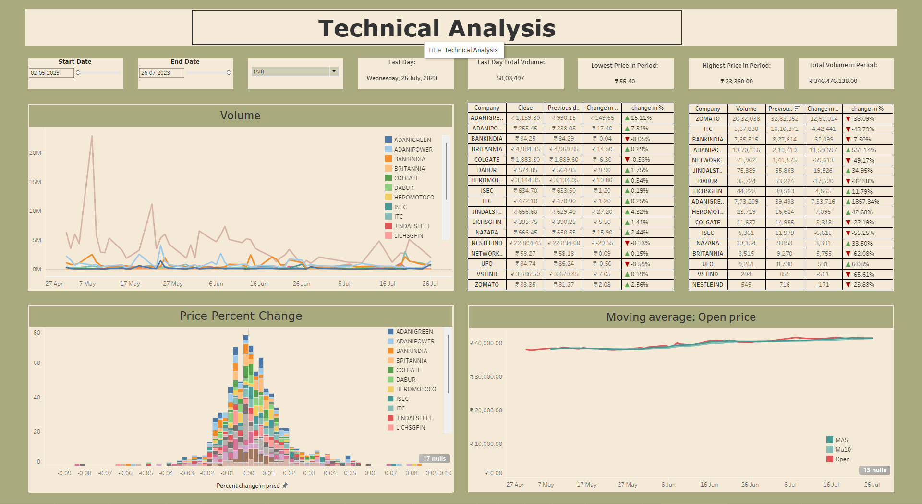

* This dashboard contains various features and KPI’s such as Start Date, End Date, Search Bar, Last Day, Total Volume on Last Day, Lowest Price in Period, Highest Price in Period, Total Volume in Period, Volume Traded, Price Percentage Change, Moving Average, Trading Terminal.
* Start and End Date – It refers to the starting and ending date of that financial quarter and it can be adjusted based on the user’s requirements. The data on the entire dashboard gets adjusted based on the inputs given in these blocks.
* Search Bar – It is a dropdown list that contains the names of all the companies that we have used here for analysis. Users can select any company and the data related to that company gets highlighted in the entire dashboard.
* Last Day – This block displays the last date of that trading session.
* Total Volume on Last Day – It displays the total volume traded of that stock on the last trading session of that period.
* Lowest Price in Period – It calculates and displays the lowest price of that stock during that entire trading period.
* Highest Price in Period – It calculates and displays the highest price of that stock during that entire trading period.
* Total Volume in Period – It sums up and displays the total volume traded of that stock during the entire trading period.
* Volume Traded – This section visualizes the volume traded of that stock in the current trading session. Users can check the volume traded of different stocks on different days to identify certain patterns and analyze trends in the buying and selling activities of that stock. We have used line charts here to display the volumes traded of each company and the companies are depicted in different colours to make it more appealing, interactive for the ease of analysis for the users.
* Price Percent change – It calculates the range of the price fluctuation of a particular stock in percentage during the entire trading period and is an important indicator to check the stability of stock prices in each trading period. More stability indicates the stock is a safer option to invest whereas less stability indicates as a riskier option to invest. We’re using bar graphs to show the range of fluctuations and different companies are denoted with different colours.
* Moving Average – This section calculates the average close price of a stock in the previous few trading sessions. Moving Average is a good indicator to identify short-term and long-term price fluctuations in the stock prices. Popular moving averages for investors are 50,100,200 Day moving averages. Here, we have used 5 and 10-day moving averages in a line graph along with the open price of the stock for that day in different colour which helps the users to compare the current price along with the 5 and 10-day moving averages.
* Trading Terminal – This section displays all the data that a Trading Terminal should include like Company Name, Close Price, Previous Day's Close Price, Change in Price, Change in Price Percentage, Volume, Previous Day’s Volume, Change in Volume, Change in Volume Percentage. Here we have used various calculated fields and formulas to calculate the above terms which helps an investor to get clarity regarding the current price and volume of the stock. We have also used arrows with a green colour indicating a positive or Upward trend whereas a Red Colour indicates a negative or Downward trend.

**4.2.2 Prototype 2 – Dashboard for Fundamental Analysis**

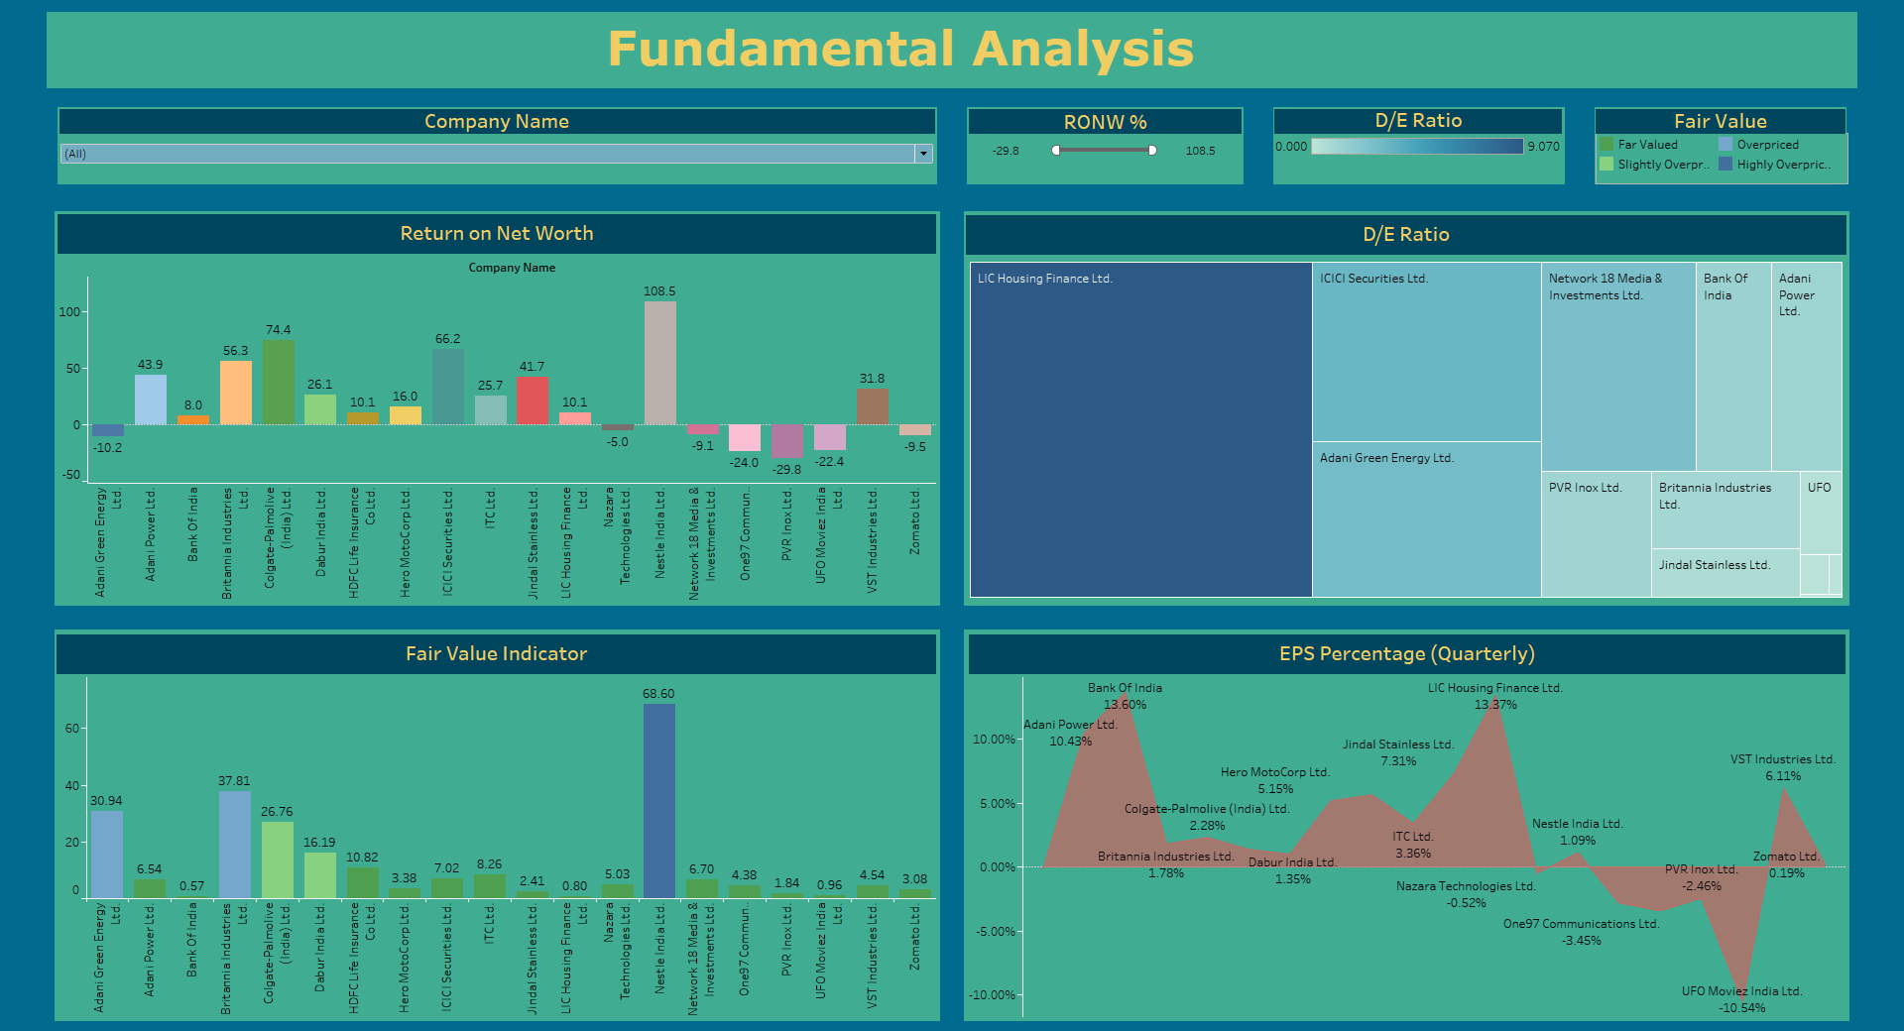

* This dashboard contains various features and KPI’s such as Search Bar for Company Name, Return on Net Worth in Percentage, Debt to Equity Ratio, Fair Value Indicator and Earnings per Share in Percentage.
* Search Bar for Company Name – It is a dropdown list that contains the names of all the companies that we have used here for analysis. Users can select any company and the data related to that company gets highlighted in the entire dashboard.
* Return on Net Worth – This section includes the data related to the profits earned by investors in past financial quarter by investing in that company. We have used a sliding bar here to help the users set the bar with a range of –29.8% to 108.5% returns and filter stocks that have given that range of returns set by the user in the last quarter. Along with that we have used coloured bar graphs to indicate the range of returns given by companies making it visually appealing and easy to identify for the users and help them invest in the right stocks.
* Debt to Equity Ratio – This includes the data related to the debt of the company compared to its equity. The lower the ratio, the lower is the company’s debt and better for the future of the company. We have used a treemap here with colours in range of Light Blue – Dark Blue where Light Blue indicates companies with Lowest or No debt whereas Dark Blue indicates companies with higher debts, and this helps users to differentiate between high debt and low debt companies and make a better decision in terms of investments.
* Fair Value Indicator – It is an indicator which says whether a stock is overvalued, fairly-valued, or under-valued. This is calculated based on the book value of the company to it’s current trading price. It helps investors to identify where the current trading price of the stock is justified based on its performance in the previous quarter. This is done by creating calculated fields, sets, bins, and parameters. The companies are divided into 4 bins ranging from Dark Green to Dark Blue Colour where Dark Green colour indicates as an undervalued company, Light Green indicates as slightly overpriced, Light Blue indicates as as overprices whereas Dark Blue indicates the company as highly overpriced.
* Earnings Per Share in Percentage – This section refers to the part of earnings which is distributed to all the shareholders on a per share basis. This is calculated using Net Profit which is divided by total number of shares. Here, we have used a calculated field and tree graphs to display this information. This helps the investors to get an estimate of average returns and dividends they may receive by investing in such stocks. A negative EPS is a big red flag to stay away from investing in such companies.

**4.2.3 Correlation Analysis**

* Correlation analysis of financial ratios involves finding correlation between these ratios to learn about the company's financial health.
* These analyses quickly break down the complex information from financial statements into simple ratios and correlations.
* For Eg – In our analysis we found that Return on Net Worth and Earnings per Share are co-related to each other which clearly indicates that investing in a company with higher EPS is more likely to give a Higher Return on Net Worth compared to investing in other companies. Such insights really help investors to take systematic investment decisions and diversify their portfolios which helps them manage risk efficiently.
* We have displayed the correlation matrix using a Heatmap with the correlation range depicted in colours ranging from dark blue to dark red where dark blue indicates no-correlation, white indicates some correlation and dark red indicates being completely co-related.
* This co-relation matrix is performed on quarterly data from the financial reports of 25 companies.

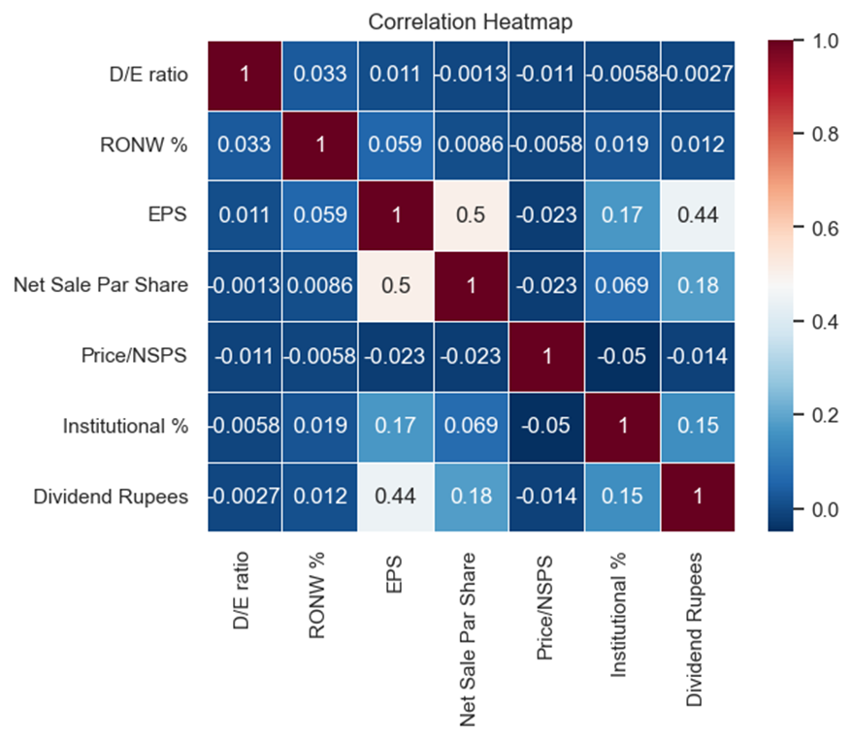

**4.3. Managerial Questions**

**4.3.1 Technical Analysis Dashboard**

* Which company’s stocks has the highest fluctuations in their prices in Quarter 1 of financial year 2023-2024?
* Which company’s stocks recorded the highest volume in trading activities during the trading period of Quarter 1?
* Which company’s stocks had the highest change in volume percentage on 26th July,2023?
* How many companies’ stock price were increased or decreased for more than 10% on 26th July 2023?

**4.3.2 Fundamental Analysis Dashboard**

* Which company had the highest Return on Net Worth during the Quarter 1?
* Which company is highly overpriced based on the financial results of Quarter 1?
* How many companies gave a negative RONW value during the entire trading period?
* How many companies have a debt-equity ratio less than 1?
* What is the EPS for Adani Power Ltd.?
* List the companies which have given a positive return on net worth, are fairly valued, has a debt-to-equity ratio less than 3 and have an EPS value of more than 4% during Quarter 1.

**4.3.3 Correlation Analysis**

* Which financial ratios are most positively correlated?
* Which financial ratios are most negatively correlated?
* Which correlated ratios have the greatest impact on the shareholders returns?

1. **IMPLEMENTATION**

As Moneycontrol wants to stay as the number one financial analysis company in India. They need to apply the proposed BI solution correctly into the organisation. In our BI solution we also tried to provide a step-by-step implementation plan for Moneycontrol as follows:

* Our BI Dashboards can be integrated into Moneycontrol's website easily as they have a great web development team and resources.
* Since Moneycontrol has already been using Tableau and dashboards in their website they already have a good BI structure with them.
* They need to integrate the fundamental data into their existing data structure for their dashboards.

For managerial implications we have created a step-by-step implementation using Kotter’s Step:

1. **Establishing a Sense of Urgency:**

Follow the trend of the financial companies using the fundamental data in the analysis. This is necessary to stay ahead of the competitors

1. **Form a Powerful Guiding Coalition:**

Hiring a strong BI team like us that knows the changes and challenges are important for the guidance this implementation needs.

1. **Create a Vision:**

Understanding that these changes need to happen to make a crucial impact on the company's growth and progress. This can also be expanded to Global market reach where moneycontrol can provide analysis platform like Bloomberg globally.

1. **Communicate the Vision:**

This vision needs to be communicated to the employees and it is necessary for them to understand the importance of project.

1. **Empower Others to Act on the Vision:**

People in the company need to understand that these prototypes and changes are backed by proven results and the growth of other companies. Since recently India has crossed the 3-trillion USD economy, these changes can bring exponential growth to the company.

1. **Plan for and Create Short-Term Wins:**

These prototype changes can be made a 2-step process where the website can be updated by one dashboard at a time. Since technical dashboard changes are easier to implement it can be done first.

After these changes, a reviews pop-up for the customers can be useful for knowing the impact of the changes.

1. **Build on the Change:**

We can also implement a Large-Language Model (LLM) which can summarize the financial articles of famous financial advisors to give external insights to the customers of moneycontrol.

Since AI has been the hot topic right now, we can provide an AI bot that can provide summary of insights as well as portfolio diversification services.

In the upcoming platform we can also integrate cryptocurrency trading and analysis.

1. **Institutionalize New Approaches**

After these changes, we can introduce moneycontrol as a new platform service that can be sold as an expert service for the customers which gives all-around analysis and insights of the financial market.

After these implementations we may suspect some technical issue which can be related to data quality. This might lead to mis information to the customers of moneycontrol. These implications can be dealt by following these measures:

* Specify the requirements for data quality:

Clearly state what your data's quality standards are. This encompasses precision, entirety, coherence, promptness, and pertinence.

* Validation of Data:

Establish validation rules to make sure the data complies with predetermined requirements. Checks for consistency, range, and format can be part of this.

* Monitoring Data Quality:

Establish routine monitoring procedures to track the quality of data over time. Set up notifications for when desired data quality standards are not met.

After these implementations we may suspects the ethical issues such as [6]:

* Mishandling of portfolio data
* Leaking of transactions details
* Leaking of personal data of customers

and Moneycontrol already has establish regulations in their organization to tackle these ethical implications such as [7][8]:

* Following ISO 14000 guidelines:

Moneycontrol.com is an ISO 14000 compliant organization, and securely maintains multiple copies of your data. Moneycontrol.com does not share your portfolio data with a third party. In addition, your access to the portfolio is now https protected, thus adding an extra layer of security. However, Moneycontrol.com may show you relevant ads based on your portfolio. This does not in any way involve sharing your data with an external entity.

* Collaborating with SEBI (Securities and Exchange Board of India):

Moneycontrol follows SEBI guidelines of securing the transactional data.

* CRM platform

Moneycontrol uses CRM platform to make sure that the customer data is secured in their organization.

1. **SUMMARY AND CONCLUSION**

In this project report we as a BI team have successfully performed this following step for Moneycontrol:

* **Researched about new trends in the field of financial analytics industry**

In the past, financial analysis was only done by using technical data of the stocks. Recently, companies are not only doing the analysis by technical data, but also by using the fundamentals of the company, by taking inspiration from Bloomberg. Moneycontrol should follow the same to stay up to date with the trend.

* **Identified the short comings of Moneycontrol’s BI platform**

We noticed that Moneycontrol’s dashboard had only real-time data and they used only technical parameters to show the information of the stocks. This does not provide a complete insight about a particular stock to their customers and may impact the investment decisions. If Moneycontrol’s doesn’t follow current trend, they might lose its competitiveness in financial analytics industry

* **Designed a futuristic BI solution for Moneycontrol**

Since we understood the current trend, we designed two prototypes and an analysis for Moneycontrol which they can provide to their customers. These designs had relevant technical parameters, fundamental parameters and important KPI’s that would be easily accessible for the customers to make data driven investments. We also made our prototypes more interactive so that they are appealing to the Moneycontrol’s customers.

* **Provided a realistic implementation plan and suggested implications solutions**

We not only provided the prototypes but also an implementation plan so that moneycontrol can smoothly integrate BI solution in their company. While following the implementations we suggested them how to keep the team motivated. We also provided the solutions for any technical, ethical and managerial implications barrier that may arise while the process of implementation.

We believe that if Moneycontrol accepts our prototypes and follows the steps of implementation that we provided they will be able to upgrade their platform as per the current trends and provide their customers with complete insight about any stock. This will help their customers to make better data driven investments and make good profits which will in turn make them choose Moneycontrol over their competitors. This will provide Moneycontrol the competitive edge that it needs to lead the global market and become the leading expert in financial industry.

1. **References:**
2. History of the company: <https://www.moneycontrol.com/cdata/aboutus.php?classic=true>
3. Technologies: <https://w3techs.com/sites/info/moneycontrol.com>
4. About Bloomberg: <https://en.wikipedia.org/wiki/Bloomberg_L.P.>
5. Case Study 1: <https://cio.economictimes.indiatimes.com/news/business-analytics/how-bloomberg-is-enabling-enterprises-to-make-data-driven-business-decisions/67669060>
6. Case Study 2: <https://www.bloomberg.com/company/press/bloomberg-empowers-event-driven-decision-making-with-real-time-data-access-on-google-cloud/>
7. Ethical guideline- <https://www.moneycontrol.com/help/portfolio/general-queries/is-my-data-with-moneycontrol-com-portfolio-private-2572157.html>
8. Sebi guideline: <https://www.moneycontrol.com/news/business/markets/sebis-annual-report-highlights-effective-international-information-exchange-and-regulatory-collaboration-11116481.html>
9. Investopedia: <https://www.investopedia.com/>